Software Requirements Specification

Version 1.0

<<Annotated Version>>

October17, 2022

Clothing Web System

Youssef Ahmed Wahba Teamleader

Abdallah khaled

Omer ashraf

Ahmed Ehab

Submitted in partial fulfillment

Of the requirements of

Software engineering course

<<Description of SRS document , SRS objectives , Describe the scope of the product that is covered by this SRS, particularly if this SRS describes only part of the system or a single subsystem >>

# Table of Contents

Table of Contents i

List of Figures ii

1.0. Introduction 1

1.1. Purpose 1

1.2. Scope of Project 1

1.3. Glossary 2

1.4. References 2

1.5. Overview of Document 2

2.0. Overall Description 4

2.1 System Environment 4

2.2 Functional Requirements Specification 5

2.2.1 Reader Use Case 5

Use case: Search Article 5

2.2.2 Author Use Case 6

Use case: Submit Article 6

2.2.3 Reviewer Use Case 7

Use case: Submit Review 7

2.2.4 Editor Use Cases 8

Use case: Update Author 8

Use case: Update Reviewer 9

Use case: Update Article 9

Use case: Receive Article 10

Use case: Assign Reviewer 11

Use case: Receive Review 11

Use case: Check Status 12

Use case: Send Response 12

Use case: Send Copyright 13

Use case: Remove Article 14

Use case: Publish Article 14

2.3 Domain requirements 15

2.4 Non-Functional Requirements 15

3.0. Requirements Specification 17

3.2 Functional Requirements 17

Index 26

# List of Figures

Figure 1 - System Environment 4

Figure 2 - Article Submission Process 6

Figure 3 - Editor Use Cases 8

Figure 4 - Logical Structure of the Article Manager Data 23

# 1.0. Introduction

## 1.1. Purpose

The purpose of this document is to present a detailed description of our Clothing Store Website. It will explain the purpose and features of the system, the interfaces of the system, what the system will do.

## 1.2. Scope of Project

Main actors of this system

* + 1. Admin
    2. User

Main use cases associated:

* Admin
* Add , edit and delete any product.
* Accept or reject the product come via link.
* Put product price for product come via link.
* User
* add, remove product or edit in short time from cart.
* Can search for any product.
* Can pay by two types (cash or visa).
* Can cancel it within 24 hours only after submitting order

## 

## 

## 1.3. Glossary

|  |  |
| --- | --- |
| **Term** | **Definition** |
| Database | Collection of all the information monitored by this system. |
| Admin | Are the people in charge of maintaining the website and have access to all the elements in the website. |
| Cart | Is a place that has all your items before you buy them |
| Developer | Is the group in charge of developing the website |
| User | Any one with a username and password found in the database |
| Consumer | Anyone visiting the site to buy cloth. |
| Software Requirements Specification | A document that completely describes all of the functions of a proposed system and the constraints under which it must operate. For example, this document. |

## 1.4. References

IEEE. *IEEE Std 830-1998 IEEE Recommended Practice for Software Requirements Specifications.* IEEE Computer Society, 1998.

## 1.5. Overview of Document

The next chapter, the Overall Description section, of this document gives an overview of the functionality of the product. It describes the informal requirements and is used to establish a context for the technical requirements specification in the next chapter. The third chapter, Requirements Specification section, of this document is written primarily for the developers and describes in technical terms the details of the functionality of the product. Both sections of the document describe the same software product in its entirety, but are intended for different audiences and thus use different language.

# 2.0. Overall Description

Admin

user

Add new product

Delete product

Clothing System

Edit product

Allow user to buy product

Generate report

Sys_log

Login/register

Add edit remove to cart

View product

Search product

Pay ( cash or visa)

2.1 System Environment

## 

The system have two active actors . which of two actor interact with each function found in website such as edit ,add, delete ,pay ,reports, register and login.

## 2.2 Functional Requirements Specification

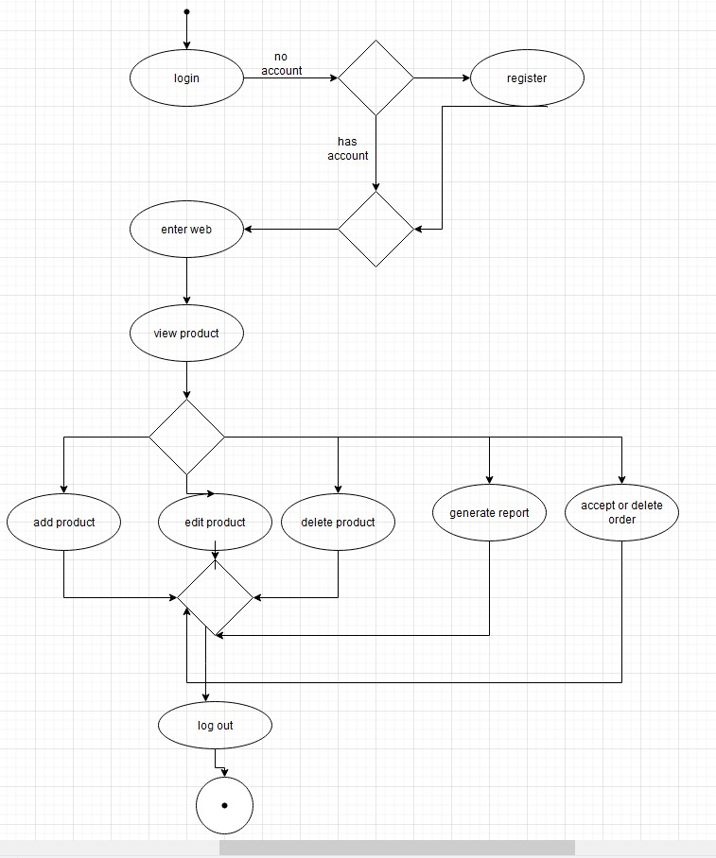

Admin

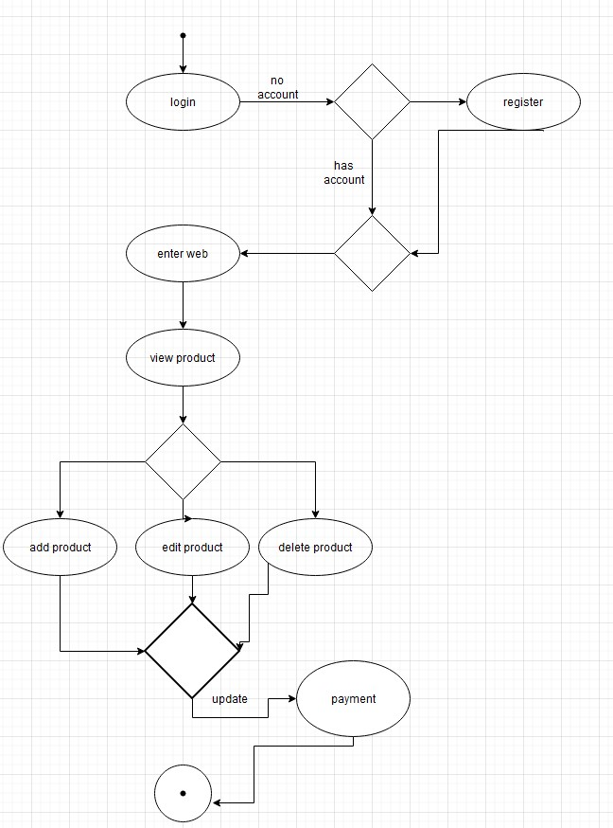

user

This section outlines the use case for user while the admin is the main actor in this system.

use case: add product

diagram:

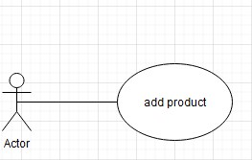

function ID:ADD PRODUCT.

function name: Add product.

brief description: user can add product in the cart by click the "ADD PRODUCT" button.

pre-condition:

post-condition:

use case: remove product

diagram:

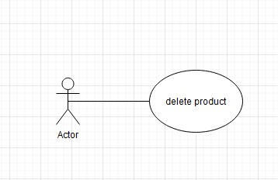

function ID:REMOVE PRODUCT.

function name:Remove product.

brief description : user can remove product in the cart by click the "REMOVE PRODUCT" button and within 24 hours after submmiting it by clicking the " remove" button.

pre-condition:

post-condition:

use case: search product

diagram:

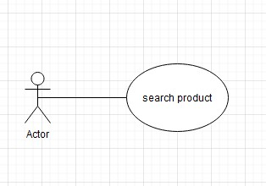

function ID:SEARCH PRODUCT.

function name:Search product.

brief description:user can search for product in the cart by click the "SEARCH FOR PRODUCT" button.

pre-condition:

post-condition:

use case: payment method.

Digram:

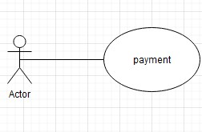

function ID:PAYMENT METHOD.

function name: payment method.

brief description: user can pay for products in the cart by click the "payment method" button and choose which method he wants.

pre-condition:

post-condition:

use case: edit product

diagram:

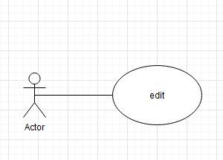

function ID:EDIT PRODUCT.

function name:edit product.

brief description: admin can edit the products info by click the "EDIT PRODUCTS" button.

pre-condition:

post-condition:

initial Step-by-Step description: before this use case user must have and email and password to login

1-the user search for the product he/she want.

2- the system displayes the choices for the user.

3-then user must select the product and click add button

4-the user can remove the product after adding it.

5-at the end user can choose the payment method (by visa or cash)

6- user can remove the order within 24 hours only after submitting it.

use case: add product

diagram:



function ID:ADD PRODUCT.

function name:Add product.

brief description: admin can add product in the cart by click the "ADD PRODUCT" button.

pre-condition:

post-condition:

-------------------------

use case: delete product

diagram:



function ID: DELETE PRODUCT.

function name: Delete product.

brief description: admin can remove product in the cart by click the "DELETE PRODUCT" button.

pre-condition:

post-condition:

use case: edit product

diagram:



function ID:EDIT PRODUCT.

function name:edit product.

brief description: admin can edit the products info by click the "EDIT PRODUCTS" button.

pre-condition:

post-condition:

-----------------------

use case: accept/ reject orders

diagram:

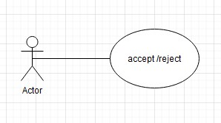

function ID:ACCEPT / REJECT ORDER.

function name: accept/ Reject order.

brief description:admin can accept order or reject it click the "accept or reject" buttons.

pre-condition:

post-condition:

use case: pricing products

diagram:



function ID:PRICING PRODUCT.

function name: pricing product.

brief description: the admin put the price for each product.

pre-condition:

post-condition:

use case: generate report

diagram:

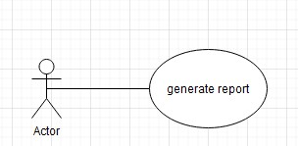

function ID: generate report.

function name: generate report.

brief description: the admin put report from statics of buying product .

pre-condition:

post-condition:

initial Step-by-Step description: before this use case admin must login using email and password

1. Add new product

2- edit in specific product

1. Remove product
2. Adding pricing
3. generate report.

## 2.3 User Characteristics

The user is expected to be able to have a decent knowledge of the internet to be able to navigate through our online website. He is expected to be able to use email to verify his mail so he can track package and receive order confirmations and have a fully working credit card that works with sufficient funds enough to make the purchase online. The user is also expected to be able to use buttons, pull-down menus and similar tools. He will also be required to be living in a suitable address which would be possible to deliver to.

## 2.4 Non-Functional Requirements

* The Online clothing website will be on a server with high-speed Internet capability so the users can have a smooth experience.
* The speed of the loading website will depend mostly on the user’s hardware device and its capabilities much more than the system’s characteristics.
* The user must sign up and enter their secure accurate information
* User confidentiality of their information is to be prioritized and kept safely away from any chance of corruption.
* The website will be made so that it is user-friendly and easy to understand for all types of people at any age.